CHAPTER 1:

THEORETICAL BACKGROUND OF THE STUDY

Muskurahat foundation was established in 2014 by Himanshu Goenka with a vision to help children living in slums, orphans, and shelter homes. This child focused non-profit has been providing free education to unprivileged children for the past 5 years now. Its an NGO that is working tirelessly to help the underprivileged children.

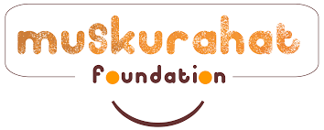

Muskurahat Foundation is an Indian Non-Government Company. It's a private company and is classified as company limited by shares. Company is registered in Delhi (Delhi) Registrar Office.

Mission of the organization:

To educate and sensitize the children and other stakeholders living in slums, orphanages and shelter homes by enhancing their upbringing and surrounding to make a better decision.

Core Values of the Organization:

LEADERSHIP

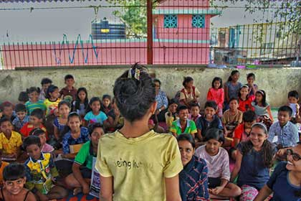Stilling the drive for change to produce a holistic individual.

INTEGRITY:

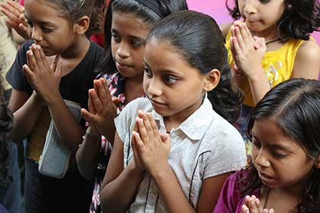Firm principles behind a strong personality to create impact.

PERMANENCE:

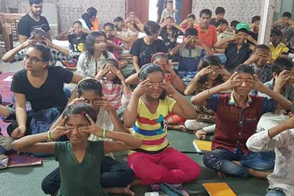Preparing sustainable plans for long term development.

COLLABORATION:

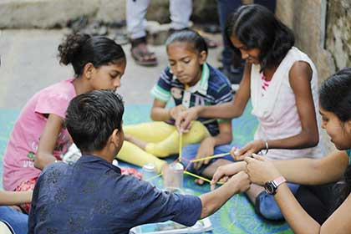Via outreach and partnering, we aim to get the young connect going.

ACCESSIBILITY:

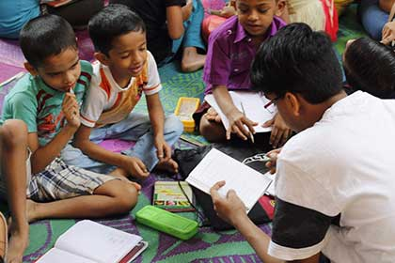Not believing in hierarchies, we promote open interaction.

CHAPTER 2:

INDUSTRY PROFILE/COMPANY PROFILE

Muskurahat Foundation is an Indian Non-Government Company. It's a private company and is classified as'company limited by shares. Company's authorized capital stands at Rs 1.0 lakhs and has 100.0% paid-up capital which is Rs 1.0 lakhs. Company is registered in Delhi (Delhi) Registrar Office.

Registrar Office City: Delhi

Company Sub-category: Indian Non-Government.

Our Theory of change

...or why we do what we do:

Children are exposed to a variety of influences that shape their lives as they grow up and participate in society. However, not all the influences they come across are positive in nature – lack of proper parenting, societal rigidity, socio-economic disadvantages, media biases and unfiltered internet can adversely affect the development of a child’s thought and value system. This gap is more evident in “at risk” children, those who grow without all or some of these influences. A child, transitioning from such a background into adulthood – unchecked, without guidance, positive reinforcements and the basic know-how of navigating life, is significantly more prone to negative influences leading to bad decisions and poor life choices.

Rationale:

Article 29 of The United Nations Convention on the Rights of the Child, in continuation of Article 28 (Right to Education), states that the Goals of Education is to develop every child’s personality, talents and abilities to the fullest. The current educational infrastructure lacks adequate focus to realize Article 29. At Muskurahat Foundation, we aim to fill this gap through our carefully curated initiatives that puts impetus on attentive upbringing, quality academic education, 21st century life skills and mental well-being of the child. We believe every child must have access to an environment conducive to positive growth. One where he/she develops the ability to learn, unlearn and relearn crucial values and life skills, necessary to live life with a healthy mindset.

How are we doing it?

Our overarching approach to create such an environment for the child rests on the firm belief that imbibing personal values, learning life skills and developing a positive mindset takes time and requires patience. For a child whose mind is continuously developing and getting influenced, our programs focus on continuous exposure to these values and skills.

We achieve this through:

Maturing our content and approach along with a child’s growth. Leaning on the principle that learning happens effectively and efficiently when it is through relevant practical experience

Consciously crafted activities and meaningful engagement with caring adults­­­ which promotes positive relationships between the child and adults.

We know it takes a village to raise a child and are therefore cognizant of the other stakeholders within the child’s environment. Our underlying aim promotes research and learning in this area through extensive monitoring data, initiating collaboration with other individuals, agencies and government to build institutions that contribute to creating an environment of holistic development for the child. Enabling the child to grow up to become a happy, independent and socially responsible citizen contributing to society.

HOW THE SMILES SPREAD?

It all started with a birthday being celebrated at an orphanage in Nalasopara on June 10th 2014. What followed gave rise to one of ‘India’s Coolest Youth Organizations’ working for a social change. The rest as they say, is History.

Not many teenagers would decide to throw their 17th birthday party at an orphanage. What sets Himanshu Goenka – the Founder of Muskurahat, apart from the average teen, is his unique vision. It was after the celebrations were over, that the seeds of this tree named Muskurahat were first sown.

After that birthday party celebration, he suddenly became aware that these kids with whom he had spent an entire day were not just orphans but also juveniles. He would have to do something about it; and do it Now.

Most of his friends continued accompanying him to these shelter homes for a short while, but after a brief period, they’d all left to pursue professional careers. Because till this day, social work is something people consider to be a side business, not to be pursued full time. Himanshu who was burning with the passion to give back, was the only one left.

So he decided to pursue it by himself and find like minded people to join his journey. It was essential that this be a youth driven Endeavour mainly because he wished to dispel the myths associated with social work that usually derogate the ability of the not-so-rich youth to mobilize for change. He soon found a zealous young team and their unbending faith is what helped Muskurahat become an established independent entity.

Joy Ride was Muskurahat’s first event where their dream was first transformed into reality. As the name suggests the idea was to take Street children on a luxurious car and bike ride along the Queen’s necklace at Marine Drive. After this Muskurahat found Muskurahat supported different causes such as menstrual hygiene cancer care as well as awareness about problems of senior citizens.

KEYtab is Muskurahat’s first flagship project which has today grown to seven centres including four in Mumbai, two in New Delhi and one in Bangalore. July 2017 was when Muskurahat set up base in Andheri, with its first office ever. Soon after this, team Muskurahat crossed the 100 volunteers mark. A few of their other projects are- Project Vastradaan- their own unique cloth donation drive for the rohingya suffering across the borders, Masika Mahotsav and Being Women 2.0.

Having come a long way, we have not only grown financially but also experientially. The existence of a full-time Core Team of eight members shows how well and how much the garden has grown. importantly, the smiles and for that we are extremely grateful.

CROWDFUNDING:

Crowdfunding is the practice of funding a project or venture by raising small amounts of money from a large number of people, in modern times typically via the Internet. Crowdfunding is a form of crowdsourcing and alternative finance. In 2015, over US$34 billion were raised worldwide by crowdfunding.

Although similar concepts can also be executed through mail-order subscriptions, benefit events, and other methods, the term crowdfunding refers to Internet-mediated registries. This modern crowdfunding model is generally based on three types of actors - the project initiator who proposes the idea or project to be funded, individuals or groups who support the idea, and a moderating organization (the "platform") that brings the parties together to launch the idea.

Crowdfunding has been used to fund a wide range of for-profit, entrepreneurial ventures such as artistic and creative projects, medical expenses, travel, and community-oriented social entrepreneurship projects. Though crowdfunding has been suggested to be highly linked to sustainability, empirical validation has shown that sustainability plays only a fractional role in crowdfunding. Its use has also been criticised for funding quackery, especially costly and fraudulent cancer treatments.

HISTORY:

Crowdfunding has a long history with several roots. Books have been crowdfunded for centuries; authors and publishers would advertise book projects in praenumeration or subscription schemes. The book would be written and published if enough subscribers signaled their readiness to buy the book once it was out. The subscription business model is not exactly crowdfunding, since the actual flow of money only begins with the arrival of the product. The list of subscribers has, though, the power to create the necessary confidence among investors that is needed to risk the publication.

War bonds are theoretically a form of crowdfunding military conflicts. London's mercantile community saved the Bank of England in the 1730s when customers demanded their pounds to be converted into gold - they supported the currency until confidence in the pound was restored, thus crowdfunded their own money. A clearer case of modern crowdfunding is Auguste Comte's scheme to issue notes for the public support of his further work as a philosopher. The "Première Circulaire Annuelle adressée par l'auteur du Système de Philosophie Positive" was published on March 14, 1850, and several of these notes, blank and with sums have survived.[15] The cooperative movement of the 19th and 20th centuries is a broader precursor. It generated collective groups, such as community or interest-based groups, pooling subscribed funds to develop new concepts, products, and means of distribution and production, particularly in rural areas of Western Europe and North America. In 1885, when government sources failed to provide funding to build a monumental base for the Statue of Liberty, a newspaper-led campaign attracted small donations from 160,000 donors.

CHAPTER 3:

APPLICATION OF THEORETICAL FRAMEWORK

FEATURES

* Leadership. Instilling the drive for change to produce a holistic individual.
* Integrity. Firm principles behind a strong personality to create impact.
* Permanence. Preparing sustainable plans for long term development.
* Collaboration
* Accessibility
* Uniqueness

WEAKNESS

Lack of a tool for collaboration and sharing.

Absence of capitalized organizational money

STRENGTHS

Time flexibility

Social awareness

Open mind and flexibility

Culture of sharing.

THREATS

Cost of technology investment.

New competitors

SWOT

ANALYSIS

OPPORTUNITIES

Modernization and innovation vision in the public sector.

Digitization and dematerialization projects

SWOT analysis is a strategic planning technique that provides assessment tools.

Identifying core strengths, weaknesses, opportunities, and threats leads to fact-based analysis, fresh perspectives, and new ideas.

SWOT analysis works best when diverse groups or voices within an organization are free to provide realistic data points rather than prescribed messaging.

CHAPTER4:

ANALYSIS AND INTERPRETATION

WORLD OF MUSKURAHAT

Muskuraahat United

PROJECT

Angaan

Siksha

PROJECT

KeyTaab

Daan Utsav

DAAN UTSAV

#DaanUtsav (earlier called the Joy of Giving Week) is India’s ‘festival of giving’. Launched in 2009, the festival is celebrated every year – commencing on Gandhi Jayanti – from October 2 to 8.

From auto rickshaw drivers to CEOs, school children to celebrities, homemakers to opinion leaders and media personnel, millions of people from all walks of life come together during this week to give their time, money, resources, or skills back to society. They do this by creating or participating in events of their choice.

A giving event could be as simple as a family taking out their maid’s children for an ice cream party, or as large as a ‘Gift Compassion’. The latter is an event that has over 10,000 schoolchildren across India making and exchanging gifts with their peers from different socio-economic backgrounds every year.

In 2016, millions of people participated in more than 1,500 events across 200 cities across the country by raising several tens of crores in money and material donations and by giving countless volunteer hours.

HOW WAS #DAANUTSAV CONCEIVED?

Several people around the world have, time and again, come together on the idea of giving back to society. It is impossible to attribute ownership to anyone for these, or likewise for #DaanUtsav!

Between November 2008 and February 2009, several individuals and NGO leaders got together and decided to launch an ‘India Giving Week’. Riverside School in Gujarat came up with a ‘Design for Change’ contest. Goonj, an NGO based in Delhi, launched the ‘Vastrasamman Campaign’. Toofles, a cause-agnostic fundraising platform, organised a ‘Style for Smiles CEO Ramp Walk’. In Chennai, a Battle of the Buffet was run. These were just some of the events; there were many more organised in the year.

The advertising agency, EuroRSCG India created the ‘Joy of Giving Week’ brand identity in March 2009. Between 2009 and 2013, as the festival grew in scale and reached all socio-economic strata and geographies of India, it became apparent that the festival needed a name that was easily understood by people across the length and breadth of the country. Thus, in February 2014, volunteers renamed the festival ‘#DaanUtsav’, based on feedback received from several people living in various parts of India.

 we are today’s keys to the doors tomorrow.

Project KEYtaab is our flagship programme. It has gone through continuous development to meet the holistic development needs of a child.

The program covers three key aspects of child development:

Social-Emotional Learning

Academic Support

Mental Well-being.

CURRICULUM FRAMEWORK:

Our curriculum follows an experiential learning approach where every concept is

broken down to its inherent value and taught in a way that facilitates learning by doing and thinking for themselves.

Primary Elements:

Social-Emotional Learning:

Continuous essential 21st century life skills such as Critical Thinking, Resilience, Communication, Decision making, etc with the underlying inculcating values (upbringing) that develops personal ethics, supporting informed decision making

Academic Support:

Changing the approach of learning by rote to learning by doing and understanding concepts in a way that helps develop a child’s perspective on gaining knowledge over passing an exam.

Mental Health:

For any intervention or behaviour change to be effective, a healthy mind is essential. Due to the nature of our consistent and regular intervention, our people on the ground are trained and equipped to identify indicators of potential mental health disorders that a child maybe growing through. This is followed with an expert counsellor intervention who works with the child to remedy it. This holds especially crucial for us owing to the background of our children who are orphans or come from unconventional families and have dealt with and/or are living with traumas.

TYPES OF CROWDFUNDING:

The Crowdfunding Centre's May 2014 report identified two primary types of crowdfunding:

Rewards crowdfunding: Entrepreneurs presell a product or service to launch a business concept without incurring debt or sacrificing equity/shares.

Equity crowdfunding: The backer receives shares of a company, usually in its early stages, in exchange for the money pledged.

Reward-based

Reward-based crowdfunding has been used for a wide range of purposes, including album recording and motion-picture promotion, free software development, inventions development, scientific research, and civic projects.

Many characteristics of rewards-based crowdfunding, also called non-equity crowdfunding, have been identified by research studies. In rewards-based crowdfunding, funding does not rely on location. The distance between creators and investors on Sellaband was about 3,000 miles when the platform introduced royalty sharing. The funding for these projects is distributed unevenly, with a few projects accounting for the majority of overall funding. Additionally, funding increases as a project nears its goal, encouraging what is called "herding behavior". Research also shows that friends and family account for a large, or even majority, portion of early fundraising. This capital may encourage subsequent funders to invest in the project. While funding does not depend on location, observation shows that funding is largely tied to the locations of traditional financing options. In reward-based crowdfunding, funders are often too hopeful about project returns and must revise expectations when returns are not met.

Equity

Equity crowdfunding is the collective effort of individuals to support efforts initiated by other people or organizations through the provision of finance in the form of equity. In the United States, legislation that is mentioned in the 2012 JOBS Act will allow for a wider pool of small investors with fewer restrictions following the implementation of the act. Unlike nonequity crowdfunding, equity crowdfunding contains heightened "information asymmetries". The creator must not only produce the product for which they are raising capital, but also create equity through the construction of a company. Equity crowdfunding, unlike donation and rewards-based crowdfunding, involves the offer of securities which include the potential for a return on investment. Syndicates, which involve many investors following the strategy of a single lead investor, can be effective in reducing information asymmetry and in avoiding the outcome of market failure associated with equity crowdfunding.

Digital security

Another kind of crowdfunding is to raise funds for a project where a digital security is offered as a reward to funders which is known as Initial coin offering (abbreviated to ICO). Value tokens are endogenously created by particular open decentralized networks that are used to incentivize client computers of the network to expend scarce computer resources on maintaining the protocol network. These value tokens may or may not exist at the time of the crowdsale, and may require substantial development effort and eventual software release before the token is live and establishes a market value. Although funds may be raised simply for the value token itself, funds raised on blockchain-based crowdfunding can also represent equity, bonds, or even "market-maker seats of governance" for the entity being funded. Examples of such crowdsales are Augur decentralized, distributed prediction market software which raised US$4 million from more than 3500 participants; Ethereum blockchain; and "the Decentralized Autonomous Organization".

Debt-based

Debt-based crowdfunding, (also known as "peer-to-peer", "P2P", "marketplace lending", or "crowdlending") arose with the founding of Zopa in the UK in 2005 and in the US in 2006, with the launches of Lending Club and Prosper.com. Borrowers apply online, generally for free, and their application is reviewed and verified by an automated system, which also determines the borrower's credit risk and interest rate. Investors buy securities in a fund that makes the loans to individual borrowers or bundles of borrowers. Investors make money from interest on the unsecured loans; the system operators make money by taking a percentage of the loan and a loan servicing fee. In 2009, institutional investors entered the P2P lending arena; for example in 2013, Google invested $125 million in Lending Club. In 2014 in the US, P2P lending totaled about $5 billion.[46] In 2014 in the UK, P2P platforms lent businesses £749 million, a growth of 250% from 2012 to 2014, and lent retail customers £547 million, a growth of 108% from 2012 to 2014.  In both countries in 2014, about 75% of all the money transferred through crowdfunding went through P2P platforms.[46] Lending Club went public in December 2014 at a valuation around $9 billion.

Litigation

Litigation crowdfunding allows plaintiffs or defendants to reach out to hundreds of their peers simultaneously in a semiprivate and confidential manner to obtain funding, either seeking donations or providing a reward in return for funding. It also allows investors to purchase a stake in a claim they have funded, which may allow them to get back more than their investment if the case succeeds (the reward is based on the compensation received by the litigant at the end of his or her case, known as a contingent fee in the United States, a success fee in the United Kingdom, or a pactum de quota litis in many civil law systems). LexShares is a platform that allows accredited investors to invest in lawsuits.

Donation-based

Running alongside reward-based crowdfunding, donation-based is second another popular form of crowdfunding.[citation needed] Donation-based crowdfunding is the collective effort of individuals to help charitable causes.In donation-based crowdfunding, funds are raised for religious, social environmental, or other purposes. Donors come together to create an online community around a common cause to help fund services and programs to combat a variety of issues including healthcare and community development. The major aspect of donor-based crowdfunding is that there is no reward for donating; rather, it is based on the donor's altruistic reasoning. Ethical concerns have been raised to the increasing popularity of donation-based crowdfunding, which can be affected by fraudulent campaigns and privacy issues.

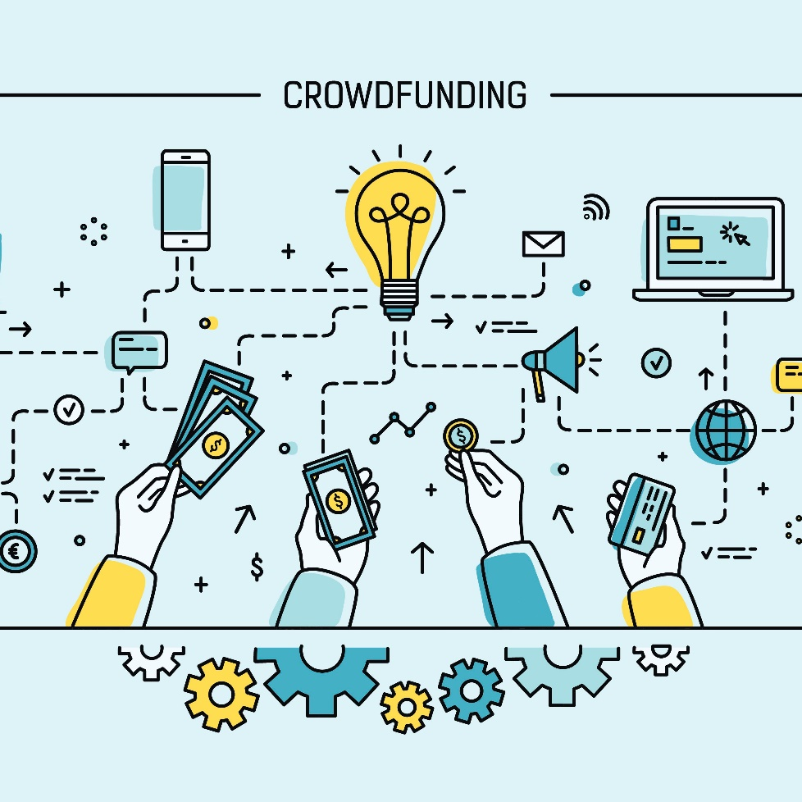

Search

The shelter home scenario in India and how we can work towards its improvement!

The lockdown during the pandemic was extremely difficult for all of us. The loneliness and anxiety everyone of us went through were very disturbing. We were locked in our homes for an insane amount of time, having nothing or very little to do.

There were a few problems that the shelter homes and NGOs faced. NGOs could not be physically present for the kids. The bond which the volunteers had established with the kids was taking a drastic hit. Many of these children have seen rash days. To build a connection and gain their trust took a lot of effort, to get them to open up was a difficult task which took a lot of attempts from the volunteers and also from the children. If we wouldn’t be in regular touch with them, then certain barriers would form again, which would take a lot of effort to break it down.

Another major problem faced was to provide regular education to the children. Whatever the circumstance, their education couldn’t be hampered. As we couldn’t be present physically to help them out, it was going to be an uphill task.

But in the face of adversity, an opportunity presents itself. At Muskurahat, we started working towards establishing a digital presence. All of this was new to us too, but we were ready for the challenge.

PROJECTS:

PROJECT KEYtaab:

Project KEYtaab is our flagship programme. It has gone through continuous development to meet the holistic development needs of a child.

The program covers three key aspects of child development:

* Social-Emotional Learning
* Academic Support
* Mental Well-being.

CLASSROOM CULTURE

In order to ensure effective learning and keeping the child at the centre of everything we do, the following elements are developed and implemented:

Safe Space Protocol: Ensuring the physical and emotional security of the children throughout the entire intervention and beyond just the curriculum intervention. Each team member of Muskurahat is trained in establishing and maintaining the safe space to ensure consistency in building the safe space.

Value system: Part of social-emotional learning, values are what we inculcate from our family as upbringing. This is largely absent in children from shelter homes who grow up without a family structure. We focus on inculcating these values such as respect, accountability, diligence, etc. as part of our sessions, using reiterations and positive reinforcements to help children imbibe and practice these values.

Mental Health: For any intervention or behaviour change to be effective, a healthy mind is essential. Due to the nature of our consistent and regular intervention, our people on the ground are trained and equipped to identify indicators of potential mental health disorders that a child maybe growing through. This is followed with an expert counsellor intervention who works with the child to remedy it. This holds especially crucial for us owing to the background of our children who are orphans or come from unconventional families and have dealt with and/or are living with traumas.

PROJECT SAARATHI:

Project Saarthi is a career readiness program targeted towards youth who are under-equipped to foster their career paths that leads to them being able to live independently. Through this project, we intend to help them identify and secure career pathways in line with their interests and current job trends, along with developing crucial work skills and work ethics.

During the first wave of the Covid-19 pandemic, a cluster of youth care-leavers (youth from the age of 18 and above who are required to leave the care of shelter homes as per the JJ Act) in Kolhapur were facing a pressing need for an income source.

The slowdown of the economy rendered these youth jobless and unable to manage their living expenses. While the temporary relief through donations was available during the initial months, it had started dwindling and raised the requirement of a regular earning source for their sustenance. The youngsters who leave the shelter homes lack awareness and exposure to career guidance, finding employment and work skills. As a result, they took up low-paying, odd jobs in the unorganized sector, which was one of the worst affected sectors during this pandemic.

Muskurahat Foundation initiated Project Saarthi with the aim to equip these youngsters to find employment on an emergency basis and work with them in the long term to identify and take steps towards building their choice of career. The long term vision of the project has been to support the youngsters in equipping them with life skills and mental health support to be able to uplift themselves from their current situation.

Muskurahat’s team arrived in Kolhapur to conduct an initial training workshop to reaffirm their needs and equip them with job readiness skills to implement on an urgent basis. The need was quickly affirmed as the participants delved into the problems they are facing and the readiness to find employment to solve their basic requirement of food and shelter. The day-long workshop was packed with identifying their existing skills and interests and matching it with the current availability of jobs in and around them. The participants were exposed to different avenues of finding jobs, preparing for application, job query and interview preparation, etc. All tangible takeaways that would help the participant to start their job search immediately and rationally. The need for on-ground training proved essential as the participants didn’t possess smartphones or reliable networks and to ensure their buy-in into the project. As we explored this segment, we realised the lack of NGO penetration in Kolhapur and surrounding areas, a result of which is the lack of exposure for the children in shelter homes. These children anyway grow up with the absence of a family that takes care of their basic needs till the time they are able to earn their own living. The requirement was urgent and for their survival, we took quick decisions to support them in the interim to resolve their immediate requirements while keeping our focus on the long term that is to help them build quality lives for themselves.

keyTaab Bangalore:

Located in the Bengaluru’s district of kodegehalli, Muskurahaat’s keyTaab chapter at Bengaluru ran for a period of around six months at a home named ‘Abhilashrayam’. Here around 25 girls around the age of 10-15 years were taught by nearly 10 volunteers.

Building skills

Post the training, we realised that the participants lacked basic English and Digital literacy skills which was crucial for the available jobs at the time such as virtual data entry jobs, tele-calling and managing data in Covid centres. Unable to find a course open to build the skill at the time, we started a temporary community centre and instituted English and Computer tutors to bridge the gap. The youth underwent basic English and Digital literacy skills to help them secure employment and build confidence.

The Result

The pilot batch of about 100 youth care-leavers saw 80% of the participants successfully identifying opportunities and taking up jobs to secure their immediate financial needs. While the rest chose to return to their relatives and prepare for their long-run educational plans.

The way forward

Though Project Saarthi was built specifically to address the needs of the youth care-leavers in Kolhapur, we realised that this is a problem across all geographies for youth who may have not had the required educational and social-emotional development necessary to make informed decisions of their career paths. Hence, we are currently working on building Project Saarthi as a progression for our children in Project KEYtaab to be able to help them transition school to college and into a profession of their choice.

EVENTS:

As per the principles of SMSD, our two projects KEYtaab and AnganShiksha look after the needs of our kids at shelter homes and in the slums. That leaves us ample space for focusing our attention on giving our support to other events of social significance. Be it our women empowerment projects such as ibtida, being women(8th March);our social upliftment endeavours in the form of our crowdfunding events like the charity bake sale or gift a child Christmas. Affirming to our core values that object all forms of stereotyping and minority exclusions, Muskurahat’s events reflects its ideological aims.

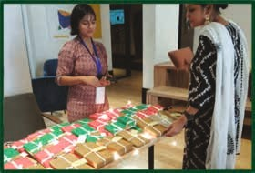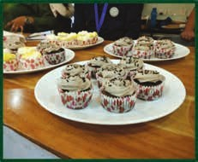

CHAPTER 5:

LEARNING EXPERIENCE:

During my internship, I quickly learned the importance of being consistent in these things. It is important to approach each day with a positive mentality regardless of what happened the previous day, we create a positive environment, increase productivity, increase energy levels and build better relationships.

First, I improved my abilities in communication by being in touch with different people and communicating them by telling them about the organization and also being a part of crowdfunding and volunteering different events such as daan utsav. It gave me opportunity to improve my language skills.

Tasks of a crowdfunding intern:

Here are the main tasks of a crowdfunding intern;

* Prospecting potential customers by phone, mail, whatsapp or by physically.
* Handling finance of the organization.
* Recruit volunteers for different events.
* Volunteers those events.
* Make people aware about the organization.
* Collecting various fund.
* Interaction with people in varsities.
* Educate people about the cause and encourage them to contribute.

**Friends of Muskurahat:**

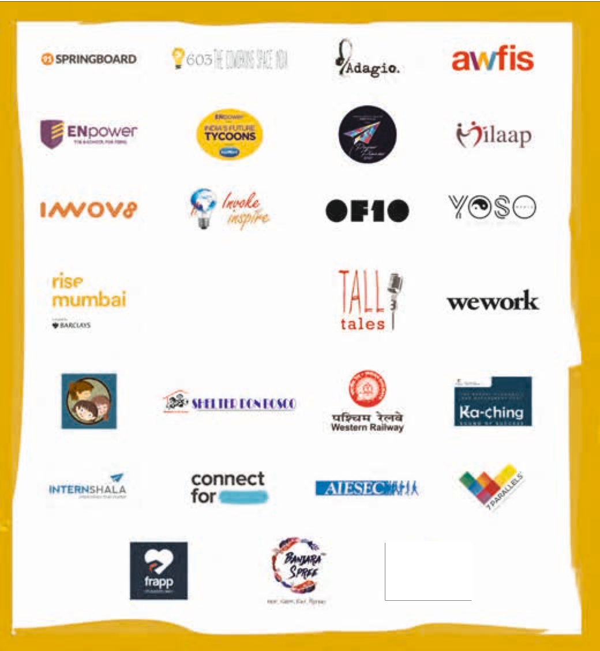

**CONCLUSION**

CONCLUSIONI have taken some time to reflect on how much I have grown in such a short period of time. I am grateful for the lessons I have learned and I am excited to continue to grow as I finish my education and enter the workforce. I hope that my article was able to shed some light on my experience as an crowdfunding intern, the challenges I have faced and some of the major lessons I have learned.